Please read the text in red and remove before finalising your policy:

This policy template has been developed in partnership with Luton Council and Growing Healthy Families to support early years settings in Luton. It outlines the key information and good practice expected within a health policy but should be adapted and updated to accurately reflect your own procedures and practice. Sections highlighted in yellow require input to ensure the policy is specific to your setting. For settings who already have policies in place (e.g. Food and Nutrition, Physical Activity or Oral Health) this template should be used as guidance to update each individual policy. Please note that this policy should not replace a food safety policy.

Introduction

The purpose of this policy is to explain the healthy lifestyle practices undertaken in this setting related to nutrition, oral health, physical activity and general health and has been developed by management with the input from staff. This policy will be distributed to parents/carers via email/website/parent app and made available in the setting as a hardcopy, should parents/carers wish to provide feedback on it. The policy will be reviewed annually or when necessary to reflect changes in national guidance.
Food Provision

Menu planning

Menus are planned to be in line with current Early Years Foundation Stage nutrition guidance which states all meals and snacks should be healthy, balanced and nutritious. This is important to ensure all children:
- Get the right amount of nutrients and energy they need while they are growing rapidly, which is especially important for children who might not have access to healthy food at home.
- Develop positive eating habits early on. Children’s early experiences with food can shape future eating habits. This can impact children’s long-term health including maintaining a healthy weight, and good oral health.

The following meals will be provided:

Meal | Time
Breakfast
Morning snack
Lunch
Afternoon snack
Tea

The menu(s) and mealtimes will be displayed in the setting/on the setting website/app/social media/shared via newsletter. Parents/carers are encouraged to feedback on our menu(s), and we will act on this feedback by…

Main meals (delete section if catered meals are not provided)

Breakfast will consist of a portion of carbohydrate, a portion of fruit/vegetable and a portion of dairy. Where cereals are provided, these will be low in sugar and salt.

Lunch and tea will consist of a portion of protein, a portion of carbohydrate, two vegetable options and a second dish. Children should also have three portions of dairy or non-dairy alternatives throughout the day and this may be provided during these meals. The second dish will either be a starter, side dish, savoury second course or a dessert. If dessert is provided, this will consist of fruit, unsweetened yoghurt, or a low sugar fruit or milk-based dessert. Catering is provided by onsite chef/name of catering company/ name of primary school.

Meeting the needs of all children

We cater to the dietary requirements of all children, including providing vegetarian/vegan/halal/kosher options. If a child has special dietary needs, this will be discussed at induction before the child joins the setting or as necessary if there are changes to the child’s diet that require extra care throughout the year. All staff involved with mealtimes will be made aware of dietary requirements and allergies through discussions and by looking at the up-to-date-list record that includes; the child’s name, dietary requirement, actions taken to avoid breaches and what to do in the case of exposure to an allergen or food not appropriate to their specific dietary requirement. At each meal or snack time, there will be a designated member of staff responsible for checking that the food being provided meets all the requirements for each child.

Food provided to children with special dietary requirements will still meet nutritional guidelines.

Allergies

Food allergies can lead to very serious or life-threatening reactions and therefore the control of allergens is taken very seriously. All staff will know how to recognise the signs and symptoms of an allergic reaction and anaphylaxis. They will also understand the differences between allergies and intolerances and that children can develop allergies at any time, especially during the introduction of solid foods which is sometimes called complementary feeding or weaning.

Before a child starts at the setting, allergy information, including a diagnosis letter from a GP or Dietitian should be provided to the setting. Providers will then work with parents/carers to create an allergy action plan, using the British Society for Allergy and Clinical Immunology (BSACI) allergy action plan. Allergy information will be reviewed regularly and updated if any changes are reported by parents or carers.

All food brought into the setting (including packed lunches) should be checked for the top 14 allergens. A designated member of staff will be responsible for checking each child’s food to ensure it is safe to eat and meets their dietary requirements.

When preparing food, the following practices will be undertaken to reduce the risk of cross contamination of allergens:
- Clearly labelling foods with their ingredients
- Storing foods and items containing allergens separately from other foods
- Washing hands regularly
- Using colour-coded equipment and utensils, or practices such as labelling a child’s cup with their name if they have a milk allergy
- Having separate preparation areas for foods that are allergens
- Having rules about visitors bringing food into the setting
If a child is experiencing a severe allergic reaction and an autoinjector (sometimes referred to as an EpiPen) has been provided by the parent/carer, this can be administered, and 999 will be called.

Intolerances

Food intolerances are typically not life-threatening but can cause unpleasant symptoms such as pain, rashes and diarrhoea, and thus will be treated seriously. If necessary, the setting staff can assist with creating a food diary to inform parents/carers of what the child is eating at the setting this can be passed on to a medical professional, to aid diagnosis.

Packed lunches

Food brought in from home should be healthy and provide a protein source, a portion of carbohydrate, a portion of dairy and a portion of fruit and vegetable. Foods high in saturated fat, salt, and/or sugars like cakes, sweet and savoury pastries, biscuits, crisps, chocolate and other confectionary are not appropriate to include in packed lunches. This includes food containing artificial sweeteners as they may encourage children to prefer very sweet foods. If these foods are found in a child’s lunchbox, the procedure is to … If these foods are persistently included in a child’s lunchbox the setting will …

State whether refrigeration is available – if not, let parents/carers know they must provide an icepack to keep food fresh until lunchtime. Also state if you are able to reheat food – if not, are they able to provide a food flask to keep food hot until lunch?

Please see the below links for inspirations for healthy lunchbox foods:
- Growing Healthy Families
- NHS Better Health: Lunchbox ideas and recipes – Healthier Families - NHS

Drinks

The only drinks provided in the setting are water and milk (or a unsweetened non-dairy alternative). This extends to lunchboxes; therefore parents/carers should refrain from providing any other drinks including fizzy drinks, juices or squash (including diluted squash).

Formula milks marketed for children aged 12 months and over (such as ‘growing-up’ milks and other ‘toddler’ milks) are not necessary. Children over the age of 6 months will be supported to drink from an open-top cup and baby bottle use will be discouraged after 12 months.

Food and dining environment

Children are required to wash their hands before every meal/snack or food-related activity. To encourage independence and social interaction at the table, children will:
- Sit together at the table
- Be supported to pour their own drinks
- Be able to serve themselves at meal or snack
- Be encouraged to clear away their own plates

Children will be seated at appropriately size chairs and tables, and use appropriately sized cutlery, cups, plates and bowls.

Staff will act as good role models but choosing healthy food and drink options and will refrain from consuming sugar-sweetened drinks, fried or high salt and sugar foods in front of children. Staff will also sit facing children whilst eating and:
- Encourage conversation, and use mealtimes as a learning opportunity, to discuss healthy foods.
- Pay close attention to detect the early signs of choking or allergic reactions.
- Pay close attention to prevent children sharing food and cross contact with allergens.
There will be at least one member of staff present who holds a paediatric first aid certificate.

If a child was to experience a choking incident that required intervention, staff will record details of where and how the child choked and ensure parents/carers are made aware. The records will be monitored regularly to identify any common features that can be addressed to reduce the risk of choking.

Celebrations and cultural events

The setting adheres to national nutrition guidance during times of celebration. This includes celebrations such as birthdays, Eid, Christmas, Hanukkah, Diwali.

The setting will be a space that protects the values of healthy eating at all times, including celebrations. For children’s birthdays, parents/carers are asked not to bring in cakes, sweets, chocolate or sweet baked goods into setting. This is also to protect any vulnerable children from exposure to allergens. Detail whether parents/carers are allowed to bring in appropriate to the setting. If yes: Parents/carers should only bring in healthy, tooth friendly foods such as fruit platters to share at snack time and all food will be checked for allergens. If parents/carers wish for children’s birthdays to be celebrated, they will be made to feel special through non-food methods such as …

On cultural or religious celebratory days, parents/carers are asked not to bring deep-fried, high saturated fat, salt or sugar foods. If parents/carers are allowed to bring in food, healthier alternatives are encouraged such as cultural foods made with less oil such as baked samosas, curries, stews, pasta salad, international fruits and vegetables. Guidance will be provided in the lead-up to the event.

Infant feeding

We are committed to promoting healthy feeding practices that support healthy development and emotional wellbeing through responsive and safe feeding practices.

We actively support breastfeeding families by:
- Including information in the induction pack on how we support breastfeeding
- Providing a private, comfortable space for mothers who wish to breastfeed within the setting
- Encourage parents who wish to provide expressed breastmilk for their children to do so. Ensuring safe storage of expressed breast milk in accordance with food safety guidelines, including clearly labelled containers and appropriate refrigeration.
- Reinforcing the message that breastfeeding is welcome and supported in our setting for example promoting the Free to Feed campaign.
- Provide evidence-based resources and support to families including signposting to breastfeeding support.

We recognise that some families choose or need to use formula milk. Our setting supports formula feeding by:

- Ensuring safe preparation and storage of formula milk, following current food hygiene and health guidance.
- Encouraging the use of first milk formula only.
- Supporting parents with information and reassurance around feeding choices.
- Maintaining clear communication with families about feeding routines and preferences.

We promote responsive feeding practices by:

- Recognising and responding to babies’ hunger (e.g. mouth opening, puckering, smacking lips, or turning of head towards the bottle) and fullness cues (e.g. milk spilling out of the mouth, closing mouth, head turning away, splayed fingers and toes, or pushing the bottle away in an older baby)
- Avoiding scheduled feeding and instead focusing on the child’s individual needs, feeding when they show signs that they are hungry, feeding at their own pace and using the cues that they are full to avoid overfeeding.
- Creating a calm and nurturing feeding environment that supports bonding and emotional wellbeing
- Providing daily updates on feeding times and amounts consumed

We support a child-led and developmentally appropriate approach to weaning:

- Solid foods are introduced in consultation with parents, typically from around 6 months, in line with NHS guidance.
- We offer a variety of textures and tastes (including finger foods) to support sensory development and healthy eating habits
- Foods is prepared safely in line with guidance on reducing risk of choking
- Staff work closely with families to respect cultural, dietary, and allergy-related needs
- Mealtimes are positive, social experiences that encourage independence and enjoyment of food

Fussy eating

It is common for toddlers and pre-school children to go through phases of fussy eating. To ensure they get the nutrients they need to grow, develop and to nurture a healthy relationship with food, staff will work with parents/carers to manage fussy eating appropriately for each child. If a child is going through a period of fussy eating, parents/carers will be signposted to fussy eating workshops delivered by Flying Start.

We use the following strategies to work with children who are considered fussy eaters:

- Have regular meal and snack times
- Guided choice: children can choose between options provided by the setting at snack times.
- Have children and adults sit together at meal and snack times.
- Involve children in mealtime routines, for example, laying the table and clearing up after meal and snack times.
- Where possible, allow children to serve themselves.
- Celebrate children for trying new foods, with no pressure to eat everything on their plates/in their lunchboxes.

Health and Lifestyle Education

Staff knowledge and training

Outline the training undertaken by staff in the areas of nutrition, food allergens, oral health, and physical activity. This should include any accredited courses, in-house training, or local authority programmes such as training provided by Growing Healthy Families. Staff apply this knowledge in day-to-day practice by: …

Supporting children and families

Explain how the setting promotes food and health education for both children and their families. Examples may include:
- Activities that explore food (e.g., growing, sensory sessions)
- Opportunities for children to engage in daily physical activity
- Sharing information, workshops, or resources with parents/carers to encourage healthy lifestyle habits at home.
- Promoting the Healthy Start Scheme, an NHS initiative that helps families buy healthy foods on a pre-card card and provides free vitamins. Families can find out more and apply online here.
- Also detail any national or local healthy lifestyle campaigns promoted within the setting (e.g., Change4Life, oral health initiatives, physical activity challenges).

Food-based and cooking activities

Provide information on food-based or cooking activities offered at the setting. Activities will:
- Be developmentally appropriate, safe, and designed to encourage children’s curiosity about nutritious foods and healthy eating habits.
- Develop children’s understanding of different foods and healthy eating.
- Engage children’s hands-on experiences preparing or tasting a range of healthy, mostly savoury foods.
- Build children’s confidence in trying new foods in a positive, supportive environment.
Oral Health

Provide information on how the setting supports oral health practices and promotes key oral health messages to families.

We actively promote oral health by: …
We also share the following key messages with families:
- Reduce the consumption of foods which have a high sugar content.
- Brush teeth twice a day.
- Children should visit the dentist as soon as their first tooth erupts and attend checkups every 6 months thereafter.
Families can find local dental practices here: https://www.nhs.uk/service-search/find-a-dentist

Supervised toothbrushing (delete section if not applicable)

We are part of the daily Supervised Toothbrushing scheme which is implemented in line with the government guidance for delivering supervised toothbrushing schemes. Supervised toothbrushing provides many benefits including:
- Better oral health for children - Daily brushing with fluoride toothpaste has proven to reduce dental decay in children
- Encourages independence and self-care
- Establishes healthy habits for life

Smoking and vaping

In line with the Early Years Foundation Stage Statutory Framework, smoking is not permitted in or on the premises when children are present or about to be present. Practitioners should not vape or use e-cigarettes when children are present.

People who chose to smoke, vape or use e-cigarettes must do this off the premises and not in sight of children, parents or visitors.

We are responsible for enforcing the smokefree law in England and can receive a penalty or fine for offences. We have clear ‘No Smoking’ signs in line with legislation.

Optional: We signpost to Total Wellbeing Luton Stop Smoking Programme for specialist information and advice.

Vaccinations

As part of promoting good health, we encourage parents to share their child’s vaccination history on entry and at key points after that. We signpost parents to information about the NHS vaccination schedule and how to access vaccinations and use this information to keep ourselves up to date.

- NHS vaccinations and when to have them
- Why vaccination is important and the safest way to protect yourself
- Booking your child's vaccination appointment
- Vaccination tips for parents
- Video: Vaccines – are they safe for my child?

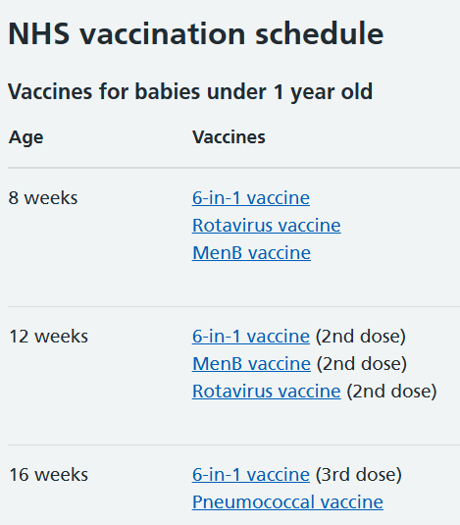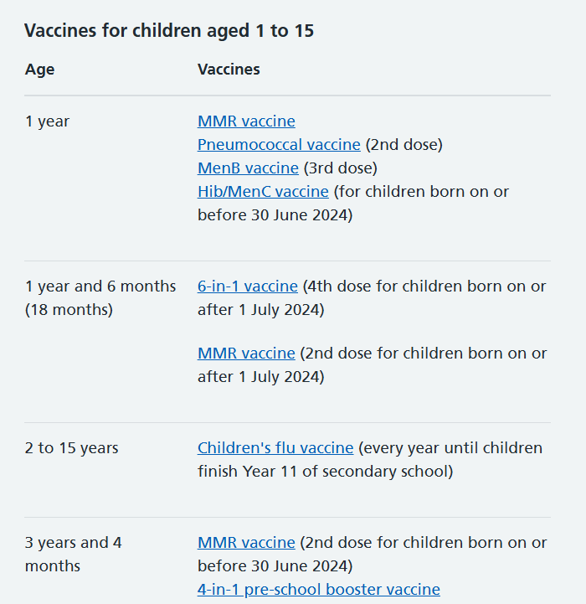

We use the promotional materials available nationally and locally to promote immunisation.

- Immunisations: resources for nurseries and schools

Staff have an awareness of infections and diseases that are known to be vaccine preventable and use the NHS resources to keep up to date.

Control of infections and managing incidents

We know What infections are, how they are transmitted and those at higher risk of infection.

Staff follow guidance on prevention and control of infections. We encourage children to wash their hands regularly and to cover their nose and mouth when sneezing and coughing to reduce the spread of infections, washing their hands and disposing of tissues afterwards. With younger children we support them to do this. Staff always clean their hands after helping a child and dispose of any tissues immediately.

Provide brief details of your cleaning schedule and how particular attention is given to food preparation, nappy and toileting areas.

We keep the setting well-ventilated and may use a CO2 monitor.

People who are showing the symptoms of an infectious disease or have been diagnosed by a health professional or diagnostic test are advised to stay away from the setting for the minimum period recommended, if required, and until well enough. We use the Exclusion table to inform us and give non- medical advice to parents. Parents are made aware of this on joining the setting.

We also promote information to parents from guidance: Is my child too ill for school? Parents are required to inform us of their child’s absence and reason. We follow us any non-attendance on the same day. If the child is well enough to come to the setting but has an infection that could be passed on, such as a cold sore or head lice, we ask parents to let us know.

We use the Luton Public Health definition of Outbreak:

An outbreak is an incident where two or more persons have the same illness/disease or similar symptoms and are linked in time, place and/or person association.

Where we have an outbreak or incident, we follow the guidance Managing outbreaks and incidents, contacting EastofEnglandHPT@ukhsa.gov.uk. We also contact Public.Health@luton.gov.uk and in the case of a food related outbreak environmentalhealth@luton.gov.uk.

Physical Activity

Physical activity
Being physically active every day is important for the healthy growth and development of babies, toddlers and pre-schoolers. Children under five need time to play and learn new skills through adult-led teaching.

The Chief Medical Office have set guidelines for the amount of time children should be physically active each day:

- Babies under 1 year are encouraged to be active in a variety of ways and should have 30 minutes of tummy times spread throughout the day.
- Toddlers aged 1-2 years should be physically active for at least 180 minutes (3 hours) each day. In the setting, children are provided with 45 minutes of physical play within each 3-hour session.
- Pre-schoolers aged 3-5 years should be physically active for at least 180 minutes each day, of which 60 minutes is moderate to vigorous intensity. In the setting, children are provided with 45 minutes of physical play within each 3-hour session.

Provide details of how you plan purposeful physical play or physical activity to develop children’s skills. This includes:

- How babies are supported to meet the guidelines, for example how you manage floor-based play and provide space for them to move freely.
- How walkers are provided with at least 45 minutes of planned physical activity every 3 hours
Provide details of how you ensure all children have the opportunity to be physically active, including those with SEND and delayed physical development.

Provide details of how you minimise the amount of time children spend being sedentary, except when they are asleep.

Provide details of how the environment is designed, and that resources are available to support purposeful physical play, indoors and outdoors. Detail how children are kept safe during extreme weather.

Families are encouraged to be physically active with children at home, including walking, cycling or scooting to the setting each day. Detail how you support active travel to the setting (e.g. space to keep bikes during the day, being part of the Early Years Eco Award) and any events or initiatives you to get families involved in being physically active with their children.

Signed: __________________________________________________
Review Date: _____________________________________________

