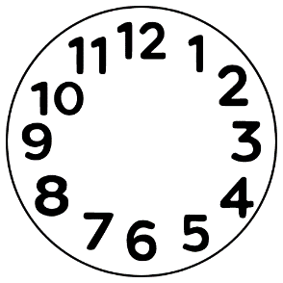
What happened? What did we do?
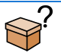
First: 

Next 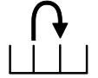

And then:
Where?
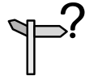
When?
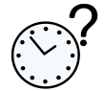
Who?


